**Lab#4**

**Implement both DFS and BFS algorithm using Python. Understand the procedure of BFS and DFS with relevance to code. Attach well commented code and output**

**DFS**

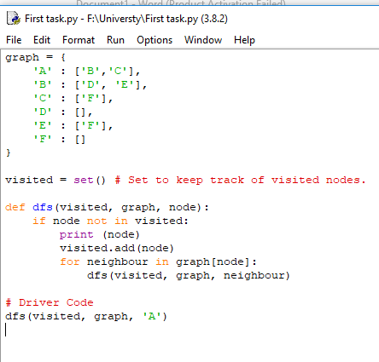

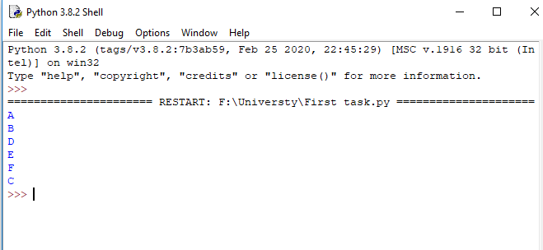

**BFS**

